Name:______________________________ Block:_________ Date: ______________
What is in the Food You Eat?
Biology Lab 2015
Do you ever read food labels or the nutrition panels on the boxes of the cereal that you eat for breakfast? These labels list the names of all the ingredients, some of which are probably familiar while others are unfamiliar. Many of these ingredients include the nutrients that supply the essential matter for your body to function naturally. The nutrients in food supply both matter and energy that your body requires for performance. Are all these nutrients equivalent? How do food scientists know what nutrients are present in particular types of food?
In this activity, you will have the opportunity to determine the presence or absence of some specific nutrients in a set of foods that Ms. Gately will provide. Read the following steps carefully.

Organize lab groups such that there are 4 people per group.
- From the list of food samples available, each member of each team should choose one food that they will test (each member of the group should test a different food). Record your choices below.

Name | Food to be tested

- Each student will conduct five different tests (protein, starch, sugar, lipids, & vitamin C) for the food they chose.
- Sets of positive and negative controls were already prepared for you. What is the significance of positive and negative controls?
________________________________________________________________________________________________________________________________________________________________________________________________________________________________________________________________________________________________________________________________________________
- Begin to fill in the your table (on the next page) by entering the different food available to be tested.
- Enter your prediction about what nutrients you will find in each of the food that the class will test. Enter a “+” sign if you think the food has a particular nutrient. Enter a “ – ” sign if you thins the food does not have a particular nutrient.
Food  Tested | Protein |  | Starch |  | Lipids |  | Sugar |  | Vitamin C
 | Pred. | Result | Pred. | Result | Pred. | Result | Pred. | Result | Pred. | Result
Note: Each student will be performing 5 different tests. Make sure you follow the protocol that pertains to the particular test you are performing, one at a time. There are 5 different protocols, outlined below.

PROTOCOL FOR PROTEIN TEST
- Place 2 ml of ground-up food in a test tube.
- Add 3 ml of water to the food and mixed it thoroughly.
- Add 10 drops of Biuret solution.
  - Biuret is an indicator. The biuret test gives a pink to purple reaction in the presence of protein.
  - No color change occurs in the absence of protein.
- Record your result in the table above.

PROTOCOL FOR STARCH TEST
- 2 ml of ground-up food in a test tube.
- Place Add 3 ml of water to the food and mixed it thoroughly.
- Add 5 drops of Lugol’s iodine solution.
  - Lugol’s iodine is an indicator. The lugol’s test turns blueish black in the presence of starch.
  - No color change in the absence of starch
- Record your result in the table above.

PROTOCOL FOR SUGAR TEST
- Place 2 ml of ground-up food in a test tube.
- Add 3 ml of water to the food and mixed it thoroughly.
- Add 1ml of Benedict’s solution.
- Place the test tube in the beaker of boiling water, and heat it for 5 minutes
  - Benedict’s is an indicator. The Benedict’s test shows an orange or brick red color in the presence of glucose.
  - The Benedict’s test shows a green color in the presence of sucrose.
  - No color change occurs in the absence of sugar.
5. Record your result in the table above

PROTOCOL FOR LIPIDS TEST
- Rub a drop of ground-up food on a piece of brown paper.
- Allow excess water to evaporate. Use heat if necessary.
- Hold the paper up to the light.
- Fats and oils make a translucent greasy spot paper.
- No translucent greasy spot appears in the absence of fats and oils
- Record your results in the table above.

PROTOCOL FOR VITAMIN C TEST
1. Place 2 ml of ground-up food in a test tube.
2. Add 3 ml of water to the ground-up food if it is solid.
- Add 8 drops of indophenol solution to the tube.
  - Indophenol is an indicator. Blue indophenol becomes colorless in the presence of vitamin C. Disregard the intermediate pink stage.
  - No color change occurs in the absence of vitamin C.
- Record your result in the table above

PLEASE READ:
- IN ADDITION TO RECORDING YOUR DATA IN YOUR TABLE, YOU NEED TO GO ENTER YOUR DATA IN THE CLASS DATA TABLE AS WELL.
- Complete your data table by entering the class data in your table.
- More than one team may have tested some foods. Enter all the results in your table. We will discuss any discrepancy in the results as a class.
Discuss the following questions with your teammates, and record your answers in the space provided.

      - How did the predictions that you made compare with the test results? ____________________________________________________________________________________________________________________________________________________________________________________________________________________________________________________________
      - Which test results were the most surprising, and why?
____________________________________________________________________________________________________________________________________________________________________________________________________________________________________________________________
      - How might the natural color of the food affect the results?
____________________________________________________________________________________________________________________________________________________________________________________________________________________________________________________________
      - Why was it important to test each indicator using water as the negative control?
____________________________________________________________________________________________________________________________________________________________________________________________________________________________________________________________
      - Why was it important to test each indicator with a substance known to contain the nutrient in
question? What is this called?
____________________________________________________________________________________________________________________________________________________________________________________________________________________________________________________________
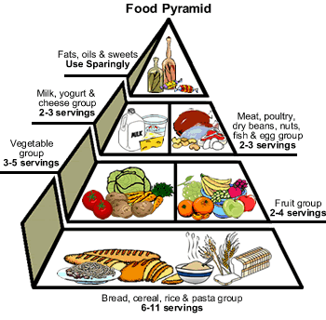
ANALYSIS
On the next page, create a food pyramid of all the food you tested in class today. Classify each food into the 6 different food groups. A sample food pyramid is shown here, illustrating the amount of each food group you should eat each day. The bread group at the bottom has the greatest number of servings, while the fats and sweets are at the top because they should be the least number of servings.
I- Fill in the food pyramid using the foods tested today.

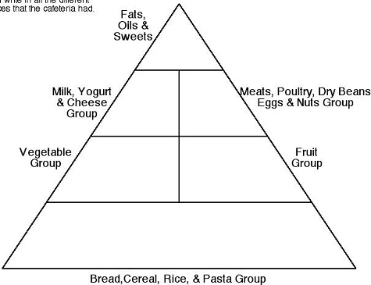
II- Based on test alone, which foods do you sometimes eat that your body can use as a source of

  - Protein? ______________________________________________________________________________
  - Starch?
______________________________________________________________________________
  - Sugar?
______________________________________________________________________________
  - Fats and oils?
______________________________________________________________________________
  - Vitamin C?
______________________________________________________________________________

III- Which, if any, of the foods that you tested contained all of the nutrients for which you tested? What
foods can you think of (that you didn’t test) might have all nutrients listed?
____________________________________________________________________________________________________________________________________________________________
______________________________________________________________________________

IV- Based on your answer for question III, what does this mean for eating a balanced diet? Are food that
have more nutrients always “better” for you? Why or why not? Do you consider your current diet to be
balanced? Either way, how could you improve it?
________________________________________________________________________________________________________________________________________________________________________________________________________________________________________________________________________________________________________________________
______________________________________________________________________________
______________________________________________________________________________

V- Write a MINIMUM one-paragraph reflection on your understanding of this lab. Using the evidence
found in your tests, what did you learn about the foods and/or the nutrients tested? What does this tell you about our diet? What will you take away from this experience?
________________________________________________________________________________________________________________________________________________________________________________________________________________________________________________________________________________________________________________________
________________________________________________________________________________________________________________________________________________________________________________________________________________________________________________________________________________________________________________________
________________________________________________________________________________________________________________________________________________________________________________________________________________________________________________________________________________________________________________________
____________________________________________________________________________________________________________________________________________________________

