What Happens to the Food You Eat? Guided Notes
pp. 376-379

Directions: Read pp. 376-379 in your textbook and answer the questions below. To help you out, the questions go in order. This information will help you write the first paragraph of your Marathon assignment. You should also study this information for Friday’s test!

1. How does your body recognize you are hungry and tell your brain you need to eat?
__________________________________________________________________________________________________________________________________________________________________________________________________________________
2. Is the “hunger” feedback system in your body positive or negative? Why?
__________________________________________________________________________________________________________________________________________________________________________________________________________________
3. What is the purpose of digestion?
__________________________________________________________________________________________________________________________________________________________________________________________________________________
4. Compare and contrast physical digestion and chemical digestion.
__________________________________________________________________________________________________________________________________________________________________________________________________________________
__________________________________________________________________________________________________________________________________________________________________________________________________________________
5. Why can our digestive processes be considered extracellular digestion, even though it happens inside our body?
__________________________________________________________________________________________________________________________________________________________________________________________________________________
_________________________________________________________________________________________________________
_________________________________________________________________________________________________________6. After you swallow, it takes food less than _________________________________ to move through the esophagus to the stomach, where as food churns and mixes with digestive fluids in the stomach for ____________________________________.

7. The coordinated contraction of digestive muscles to move food through the digestive tract is known as ____________________________________

8. Use Figure 7.23a to fill in the Digestive System Diagram below.
***You should absolutely know this information for Friday***
NOTE: In the diagram below, you should label the gall bladder, even though it is not directed labeled in the textbook. Can you figure out where it is??
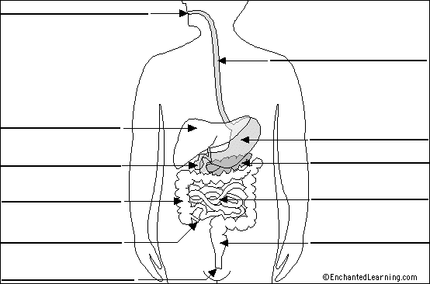

9. Use Figure 7.23b and Figure 7.24 to fill out this chart below.
NOTE: The headings should be read across as a sentence, filling in the appropriate info.
***You should absolutely know this information for Friday***
In the… | enzymes such as… | break down… | into…
Mouth |  |  | simple sugars
Stomach |  | proteins
Small intestine | lipase

10. Provide an example of negative feedback during the digestive process:
_________________________________________________________________________________________________________
_________________________________________________________________________________________________________
11. Glands in the stomach secrete _________________________________ which helps break down food, but can also destroy living tissue. To protect the cells, the stomach is lined in a thick coat of ___________________________.
12. Does food get broken down into their final building blocks in the stomach? ____________
If not, where does the final digestion of food components happen? ____________________________

13. Bile is stored in the _________________________________, and contains bile salts that break down ______________, so __________________________ can work on them easily.

14. What are the end products of digestion? ______________________________________________________
_________________________________________________________________________________________________________

15. What is the purpose of villi in the small intestine? ___________________________________________

16. Inside each villi are blood vessels called _________________________________ that allow the end products of digestion to move into the ____________________ to be carried to cells throughout the body.

17. What is biosynthesis? ___________________________________________________________________________
_________________________________________________________________________________________________________

18. Describe how glucose is stored, and then how it can be used:
_________________________________________________________________________________________________________
_________________________________________________________________________________________________________

19. Water absorption occurs in the ____________________________________, where almost no food absorption occurs.

20. What is feces composed of? ____________________________________________________________________

21. In addition to the processes already described, there are almost millions of good bacteria that live in our small and large intestines. They help you _____________________________,
and ________________________________ can disrupt their normal processes, sometimes causing an upset stomach.

Now flip to the back page and follow the instructions to write your final two paragraphs.
Marathon Assignment Paragraph Writing
1. Using the information from this packet, along with the admit slip discussion, to write the first paragraph of your Marathon Assignment. (This should be your first in terms of order, but your 5th in terms of completion.) Here are the instructions from the assignment:
Explain how humans obtain energy. You should discuss digestion and biosynthesis in your answer.
Then explain how physical fitness is related to the release of energy from matter. (1+ paragraphs)

_______________________________________________________________________________________________________________________________________________________________________________________________________________________________________________________________
______________________________________________________________________________________________________________________________________________________________________________________________________________________________________________________________________________________________________________________________________________________________________________________________________________________________________________________________________________________________________________________________
__________________________________________________________________________________________________________________________________________________________________________
2. For the 6th and final paragraph of your Marathon Assignment, go to the class website under Homework/Handouts and watch Videos 1-3 on Proteins and Muscles. Take notes and rewind as needed, then write your final paragraph below. Here are the instructions:
Explain how digestion, breakdown, and biosynthesis relate to the
repair of a torn muscle in a marathon racer. (1+ paragraphs)

____________________________________________________________________________________________________________________________________________________________________________________________________________________________________________________________________________________________________________________________________________________________________________________________________________________________________________________________________________________________________________________________________________________________________________________________________________________________________________________________________________________________________________________________________________________________________________________________________________________________________________________________________________________________________________________________________________________________________________________________________________________________________________________________

