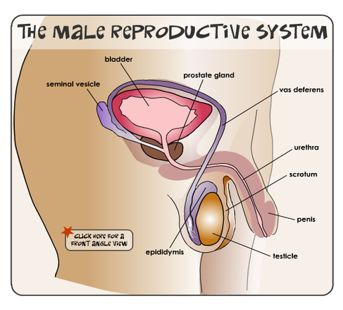
Bladder- holds the urine

Testes- male gonads; produce sperm

Prostate gland- produces and adds more fluid to the semen

Semen- white sticky fluid that carries and nourishes sperm

Seminal vesicles- contribute to the production of semen

Epididymis- sperm travel here after the testes to wait until they are mature (2 weeks), but can stay for months until ejaculation; after that, they disintegrate

Vas deferens- carry sperm from the epididymis to the urethra

Urethra- passageway for both urine and sperm

Scrotum- loose sac of skin and muscle that houses the two testes

Penis- made of shaft and glans (rounded tip), sometimes covered by foreskin if not surgically removed (circumcision)

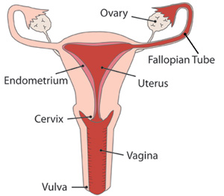

Ovary- female gonads, each month one of them releases a mature ovum

Fallopian Tube- (also called Oviduct), moves ovum to the uterus; ovum must be fertilized by sperm within 24 hrs inside fallopian tube

Uterus- thick-walled, pear-shaped organ that stretches to hold the growing fetus

Endometrium- mucous membrane lining the uterus; thickens during menstruation to prepare for baby

Cervix- narrow portion of uterus, connects the internal and external organs; opens to 10 cm during childbirth to fit baby’s head

Vagina- muscular tube; penetrated during intercourse and stretches during childbirth

Vulva- external female organs (includes labia- folds that protect genitalia, and clitoris)

