Reproductive Anatomy: Pre-Test

Directions: Taking your best guess, label all the parts below for the male and female reproductive tracts. How well do you know your own body??
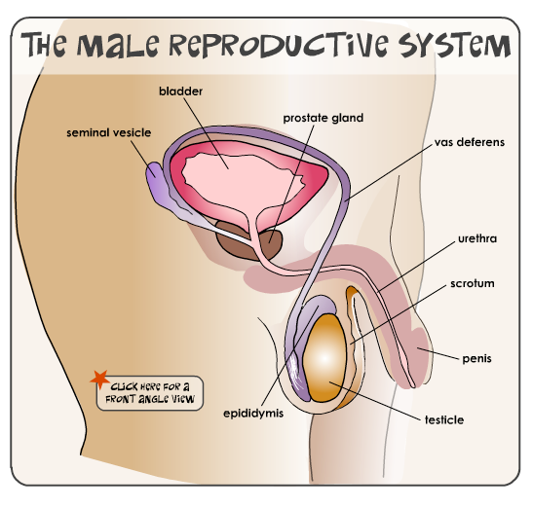
Word Bank:
bladder
prostate gland
penis
testicle
epididymis
urethra
seminal vesicle
scrotum
vas deferens
The Female Reproductive System

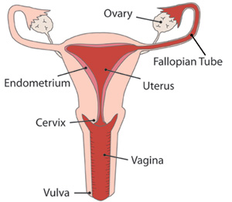
Word Bank:
ovary
uterus
endometrium
cervix
fallopian tube
vagina
vulva

Reproductive Anatomy: Answers

Directions: Looking at the diagrams on the board, fill in the correct information.
Word Bank:
bladder
prostate gland
penis
testicle
epididymis
urethra
seminal vesicle
scrotum
vas deferens
The Female Reproductive System

Word Bank:
ovary
uterus
endometrium
cervix
fallopian tube
vagina
vulva

