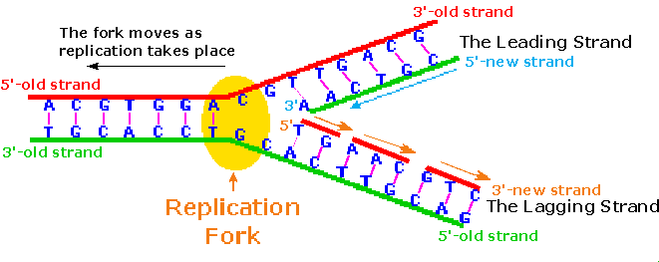

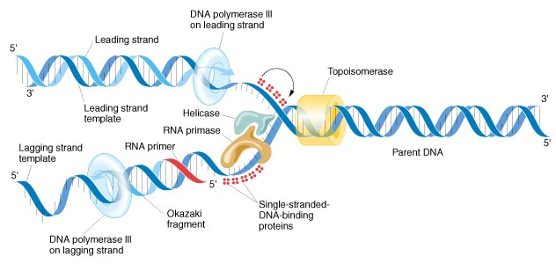

DNA Replication Review
Directions: Using the images on the back of this page, describe the meaning or role of each of the following in DNA replication:

- Leading Strand:

- Lagging Strand:

- Replication Fork:

- Parent DNA:

- Daughter DNA:

- Topoisomerase:

- Single-stranded DNA-binding proteins:

- Helicase:

- DNA polymerase III:

- RNA primase:

- RNA primer:

- Okazaki fragments:

