Concept Map of Ovulation/Menstruation

_________________________________ in brain releases gonadotropin releasing hormone (________________) into blood vessels in _________________________ gland stimulates pituitary gland to produce follicle stimulating hormone (___________) travels through blood stream to ______________________ FSH helps mature the __________________ in the ovary hypothalamus makes more ______________ stimulates pituitary to secrete luteinizing hormone (___________) during peak of LH in blood, ovary releases ____________ (ovulation) egg travels through _________________________ tube until it reaches the _______________________ empty follicle turns to __________________________ secretes progesterone and _____________________ prepares _________________ for pregnancy (thickens lining the lining known as the ___________________________)
If egg is fertilized, _____________________________ continues to secrete progesterone to help nourish embryo
If the egg is not fertilized, hormone levels _________________, and the lining is shed
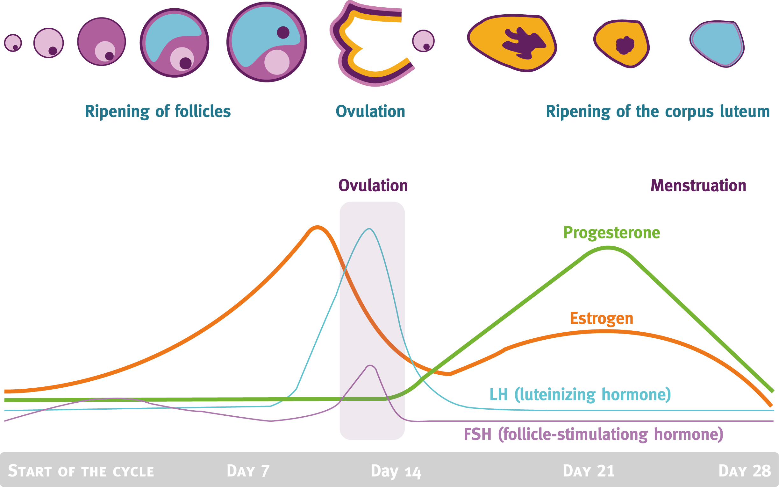

Answer key:

Hypothalamus in brain releases (gonadotropin releasing hormone) GnRH into blood vessels in pituitary gland stimulates pituitary gland to produce follicle stimulating hormone (FSH) travels through blood stream to ovaries FSH helps mature follicle in ovary hypothalamus makes more GnRH stimulates pituitary to secrete luteinizing hormone (LH) during peak of LH in blood, ovary releases egg (ovulation) fallopian tube uterus
empty follicle turns to corpus luteum secrete progesterone and estrogen prepares uterus for pregnancy (thickens lining- endometrium)
If egg is fertilized, corpus luteum continues to secrete progesterone to help nourish embryo
If the egg is not fertilized, estrogen levels decrease, and the lining is shed

