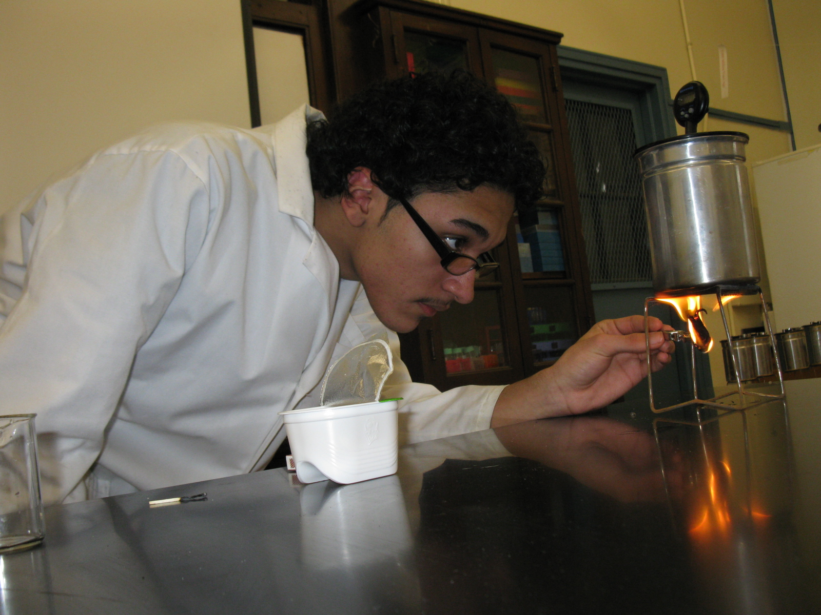
Calorimetry Lab
Introduction: During the Marathon Assignment you read about four individuals who trained for and completed a marathon. Prior to engaging in such an energy-depleting activity, athletes often eat meals that are high in carbohydrates. This is why athletes often eat pasta before their big game or race, because the carbs in the pasta provide an energy reserve for use the following day. All foods contain energy, but the amount of potential energy stored within each food will vary greatly depending on the type. Moreover, not all of the stored energy is available to do work. When we eat food, our bodies convert the stored energy, known as Calories, to chemical energy, thereby allowing us to do work. A calorie is the amount of heat (energy) required to raise the temperature of 1 gram (g) of water 1 degree Celsius (°C). When we talk about caloric values of food, we refer to them as Calories (notice the capital “C”), which are actually kilocalories. There are 1000 calories in a kilocalorie. So in reality, a food item that is listed as having 38 Calories has 38,000 calories. Calories are a way to measure the energy you get from the food you eat. A calorimeter is the instrument used to measure, in calories, the amount of energy in foods. By using a simple calorimeter and a thermometer, you can measure the change in temperature of a known volume of water, because the water absorbs the heat given off by burning a known mass of food. Based on the change in temperature, you can calculate the amount of energy in the food.
Pre-Lab Questions:
- All foods have energy. Agree or Disagree
- All of the stored energy is available to do work. Agree or Disagree
- What is a calorie? (note the small “c”)
______________________________________________________________________________
______________________________________________________________________________
- What is a calorimeter?
______________________________________________________________________________
______________________________________________________________________________
- Read the procedure and complete the Procedure Check questions that follow.
Objectives:
- SW measure the amount of energy stored in food
- SW investigate various sources for energy lost in their calorimetry apparatus system
- SW identify & assemble the necessary instrument to measure calories
Materials:

- goggles
- matches
- calorimetry apparatus
- thermometer
- 100 mL graduated beaker
- alligator clip
- water bottle
- wire gauze stand
- analytical balance
- food of various types

Procedure:
- Select the three foods that your team chose to test.
- Gather your equipment and report to your station.
- Assemble the calorimetry apparatus as demonstrated.
- Now, disassemble the calorimetry apparatus.
- Using your graduated beaker, add 50 mL of water into the smaller container of the apparatus.
- Reassemble the calorimeter apparatus.
- Insert the thermometer into the opening of the apparatus lid.
- Place the apparatus onto the wire gauze stand.
- Report to the demonstration bench to weigh your food sample.
Note: As one or two people are working on putting the apparatus together, someone else should be weighing the food samples and recording the data.
- Read and record the initial temperature of the water.
- Use the alligator clip to gently grasp the food.
  - If the food breaks, try another end of the food.
  - If breaking of the food persists, ask for another sample.
  - If you obtained a new sample, make sure to weigh the new sample.
- Once the food is secured in the alligator clip, use the light source to ignite the food.
- Immediately upon igniting the food, place it under the apparatus setup.
Note: Keep rotating the flame such that the fire does not extinguish – as demonstrated.
- Once the food is burned to a crisp and the fire is extinguished, continue monitoring the temperature of the water until it starts going down. This might take about three to five minutes.
- Record the final temperature of the water.
- Allow the apparatus to cool down for about two minutes before disassembling.
- Repeat steps 4 through 16 with the other two food samples.
- Clean your area and wash the larger container with the provided pad such that its original metallic shine is restored.

Procedure Check:
NOTE: These questions MUST be correctly answered in order to begin the lab.

1. You will be testing three different food samples. Including the practice setup outlined in the procedure, how many times will you be setting up the calorimeter, and how many times will you be disassembling it?
Assembling: __________ times Disassembling: ___________ times
2. How much water will be added to the smaller container of the apparatus: ________________________
3. Where will the thermometer be inserted? _________________________________________________
4. What is the alligator clip used for? _______________________________________________________
5. When should the food be placed under the apparatus setup? ___________________________________
6. The flame should be a) rotated or b) held still (circle one). Why? __________________________
7. You should burn the food until it is __________________________ and the fire is ________________
8. You should take the temperature at two points- first when the food initially finishes burning, and a second time when the water reaches its highest temperature, which may take ________________ minutes.
9. How long do you let the apparatus cool down before dissembling after each use? __________________
10. Upon completion, you should clean the large container until _________________________________

Data Table:
Food | Mass (g) | Initial Temp. of Water (°C) | Final Temp. of Water (°C) | Change in Temp. of Water (°C) | # of Calories in Food
(4th food optional):
Analysis/Discussion:
Conversion: 1 mL water = 1 gram water
Formula 1: calories = change in temp. * volume of water
Formula 2: kilocalories = calories / 1000
Formula 3: kcal/mass = kilocalories / food sample mass
Formula 4: Calories generated per gram of food =
(change in temperature * mass of water heated) / (mass of food burned)

- Describe your experimental observations:
_______________________________________________________________________________
_______________________________________________________________________________
_______________________________________________________________________________
_______________________________________________________________________________
_______________________________________________________________________________
_______________________________________________________________________________
- Which of the three foods you tested has the most calories?
_______________________________________________________________________________
- Which of the three foods you tested has the least calories?
_______________________________________________________________________________
- If you have a 50 grams of pringles, and through calorimetric analysis you find out that it produces a change in temperature of 30 °C. Calculate the calories content of the bag.

- A bag of nuts weighs 200 grams. Its change in temperature upon burning is 50 °C. What is the Calorie content of the bag?

- A 100-gram bag of Sun chips is burned through calorimetric analysis. It produces a 20-degree change in temperature. What is its Calorie per gram content?

- Calculate the Calorie (Kcal) / Mass of all three foods you tested:
Food | calorie | Calorie (Kcal) | Calorie / Mass

Show work here:

- Based on your observations, discuss the nutritional value of the foods you tested. Because these are food traditionally consumed by teenagers, what does this say about the typical teenage diet?
_______________________________________________________________________________
_______________________________________________________________________________
_______________________________________________________________________________
_______________________________________________________________________________
_______________________________________________________________________________
_______________________________________________________________________________
_______________________________________________________________________________
_______________________________________________________________________________
- What form of energy did you harness to complete this lab? How was this energy used to give you quantitative data? Going off that idea, identify one aspect of experimental error that may have affected the results, and suggest how this might be avoided in future trials.
_______________________________________________________________________________
_______________________________________________________________________________
_______________________________________________________________________________
_______________________________________________________________________________
_______________________________________________________________________________
_______________________________________________________________________________
_______________________________________________________________________________
_______________________________________________________________________________

