Anorexia Nervosa: Dying to Be Thin

Directions: Read the blurb and write a response answering the questions below.

Christine has been getting increasingly moody and she hasn’t had her period (menstruated) in three months. The circles under her eyes make her look like she hasn’t been sleeping well. The cold she caught two weeks ago has lingered on and on. Though she denies feeling tired, she seems to have less energy each day. Yesterday, her father noticed her swaying a bit—dizzy, perhaps? —when she jumped up to answer the phone. Dinner was an unhappy meal. Her parents pushed her to eat, and Christine insisted she was not hungry. Then she went out to run her customary 3 km (1.9 mi).
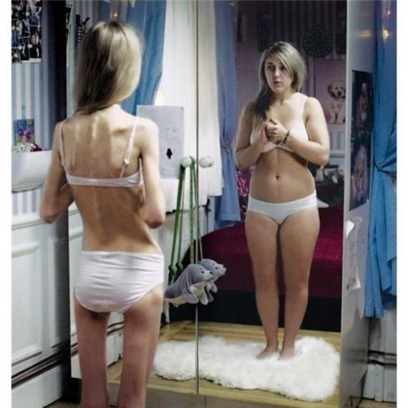
Although Christine doesn’t know it, she has anorexia nervosa. Anorexia nervosa is an eating disorder that affects an estimated 1 million people, mostly teenage girls, in the United States. Christine probably wouldn’t admit that she is undernourished. In fact, she will insist against all evidence to the contrary that she is fat and needs to lose weight. She denies her hunger and exercises relentlessly until she is convinced that she has burned off any “excess” calories she might have consumed. Her friends admire her self-discipline, but they also worry about her. Left untreated, Christine likely will continue starving herself, possibly to death. As her nutritional base deteriorates, she will experience profound physical changes. Her reproductive hormone levels will continue to drop. Her heart muscle will become weak and thin, as her body breaks down its structural proteins as a source of energy. Her digestive system will begin to function less and less efficiently. Electrical activity in her brain may become abnormal. Electrolyte imbalances in her body will put her at risk for sudden heart failure.
Treatment of anorexia nervosa is complex. The underlying causes involve self-image and mental attitudes. Successful treatment must take into account the whole person: the physical self, the cultural self, and the psychological self. Not surprisingly, treatment is most successful when the entire family is involved and participates honestly in the process.

Your Task: Pretend you are Christine’s doctor who must explain what is causing her symptoms (lowered hormone levels, weak heart muscle, deteriorating digestive system). Use your knowledge of energy breakdown in the body (what is the order again??), and how that is contributing to her poor health. Then, prescribe treatment. What should she change about her habits, and how would that improve her health?

On the back of this page, write your response to the above prompt, completely addressing all components in 1-3 paragraphs.
Doctor: ______________________________ Patient: __________________________Diagnosis: _______________

Doctor’s Treatment Notes

___________________________________________________________________________________________________________________________________________________________________________________________________________________________________________________________________________________________________________________________
______________________________________________________________________________________________________________________________________________________________________________________________________________________________________________________________________________________________________________________________________________________________________________________________________________________________________________________________________________________________________________________________________________________________________________________________________________________________________________________________________________________________________________________________________________________________________________________________________________________________________________________________________________________________________________________________________________________________________________________________________________________________________________________________________________________________________________________________________________________________________________________________________________________________________________________________________________________________________________________________________________________________________________________________________________________________________________________________________________________________________________________________________________________________________________________________________________________________________________________________________________________________________________________________________________________________________________________________________________________________________________________________________________________________________________________________________________________________________________________________________________________________________________________________________________________________________________________________________________________________________________________________________________________________________________________________________________________________________________________________________________________________________________________________________
__________________________________________________________________________________________________________________________________________________________________________________________________________________

